**Lab Exercise 10**

**Creating and Executing a Basic GitHub Actions Workflow**

**Objective:** To create and execute a basic GitHub Actions workflow for automated testing and deployment, enhancing the efficiency and reliability of project development processes

**Tools required:** GitHub

**Prerequisites:** None

Steps to be followed:

1. Create a new GitHub repository
2. Create and execute a new workflow file

**Step 1: Create a new GitHub repository**

1. Open the browser in your lab, go to **github.com**, and log in to your account

**Note**: If you do not have a GitHub account, visit the official website at <https://github.com/signup> and create a new account

1. Click on the **+** icon from the upper-right corner of the page and select **New repository** from the drop-down menu

1. Enter the name and description for the GitHub repository

1. Choose **Public** for the repository type

1. Select **Initialize this repository with a README** to include a README file for the repository

1. Click on the **Create repository** button

The remote GitHub repository is created.

**Step 2: Create and execute a new workflow file**

1. Navigate to the **Actions** tab and click on **set up a workflow yourself** to create a **.github/workflows** directory

* 1. Create a new workflow file **basic-workflow.yml** with the below code, then click on **Commit changes**:

**name: GitHub Actions Demo**

**run-name: Testing out GitHub Actions**

**on: [push]**

**jobs:**

**Basic-Workflow:**

**runs-on: ubuntu-latest**

**steps:**

**- run: echo " Job is executing as part of Basic workflow"**

* 1. Add the **Commit message** as **Create basic-workflow.yml** and then click on **Commit changes** to save the workflow file in the code repository

* 1. Navigate to the **Actions** tab to access the workflow execution, and under **All workflows,** click on the **Testing out GitHub Actions**

* 1. Click on the **Basic-Workflow** to view the job execution details

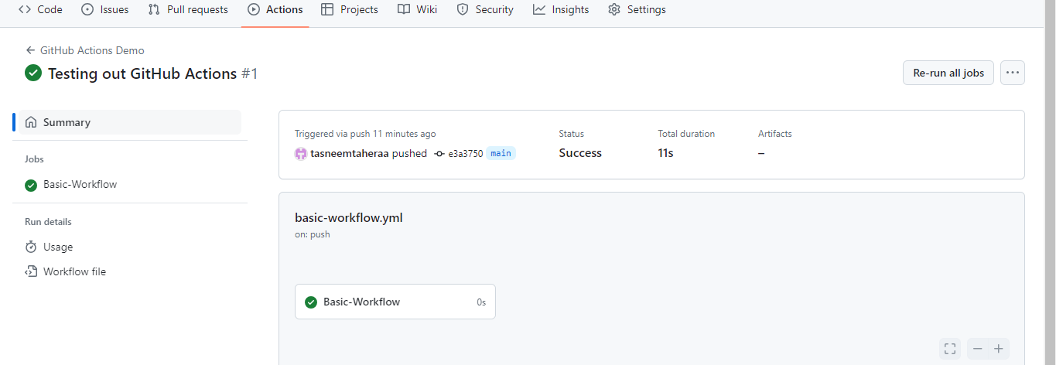

The **Basic-Workflow** screen will appear as shown below:

2.6 Expand the output under the **Basic-Workflow**

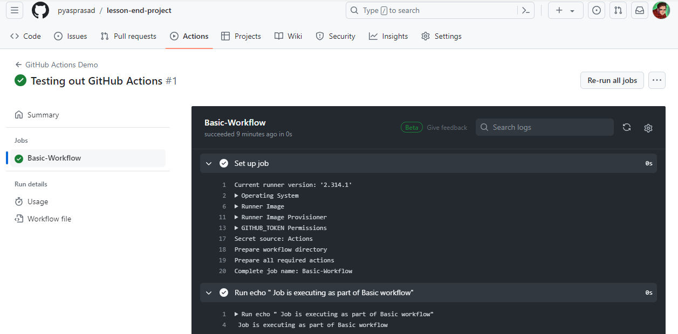

By following these steps, you have successfully created and executed a basic GitHub Actions workflow for automated testing and deployment, enhancing the efficiency and reliability of project development processes.